Loans
What is BioLink Loans? 2
Creating new loans 2
Finding existing loans 2
Editing and deleting loans 2
Loan details 2
General tab 2
Material tab 3
Correspondence tab 4
Reminders tab 4
Managing reminders 5
Traits and Notes tabs 6
Adding Traits 6
Adding Notes 6
Loan forms 6
Creating a loan form 6
Adding a loan form to BioLink 9
Loan form tags 9
Contacts 10
List of loans for a person 10
Contact details 10

What is BioLink Loans?
BioLink Loans provides a tool for managing loans of material. A range of details about loans can be tracked, including borrower’s details, due dates and return dates, methods of transfer, lists of material sent and returned and lists of correspondence. It also includes a reminders facility. A Contacts Manager is included to manage addresses, phone numbers and similar information.

Creating new loans
To add a new loan select the Add New Loan menu item under the Tools→Loans menu. Alternately, a new loan can be created from the Find Loans window by pressing the first toolbar button. This will open the Loan Detail window where information for the new loan can be entered. See below for information managed for each loan.

Finding existing loans
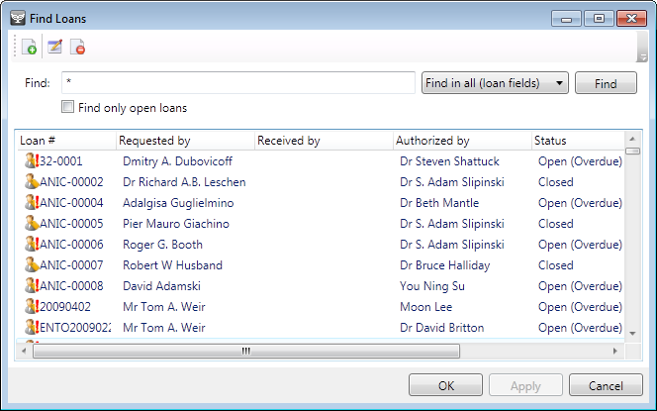
The Find Loan window is used to locate loans. To open this window select the Find Loans command under the Loans button on the main BioLink toolbar. Once open, enter a search term in the Find box, optionally select the type of item to search for in the list box to its right, and click the Find button. To include only those loans that are currently open check the Find Only Open Loans checkbox. A list of loans matching the search term will be returned in the lower part of the window.

Editing and deleting loans
To view details of a loan, select it in the list and press the second toolbar button or click the right mouse button or open the Edit menu and select the Edit Details command. To permanently delete a loan select it in the list and press the third toolbar button or click the right mouse button or open the Edit menu and select the Delete command.

Loan details
The Loan Detail window contains information on loans. To open this window select the Create New Loan command from the Tools→Loans menu. Locating a loan using the Find Loan can also open this window or Loans for a Contact windows and selecting the Edit Loan command.
Loan forms can be printed directly from this window. Pressing the Generate Loan Form button near the bottom left of the window will open a list of available loan forms. Select the required loan form and press the OK button. This will automatically generate the loan form and transfer it to a word processor for printing. For details on managing loan forms see Loan Forms below.

The following information is stored for each loan. This information is grouped on a set of tabs as outlined here.

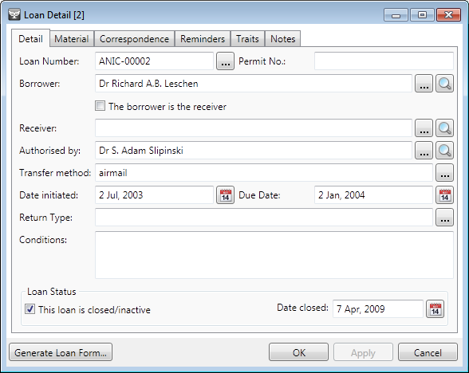
Detail tab
Loan Number: The number of the loan. This can be any combination of numbers, letters and symbols. Pressing the ellipsis button (with the three dots) to the right of the field will open the Automatic Number Generation Window. This window can be used to automatically find the next available loan number.
Permit Number: The export or collecting permit number associated with this loan or its material.
Borrower: The name of the person to whom the loan is officially sent (see also Receiver below). This name can be typed directly into the field or transferred from Contacts. If typed directly, BioLink will look up the name in Contacts. If a single match is found, the matching name will be used. If more than one match is found, a list of names will be displayed where the appropriate name can be selected. If no matches are found an error message will be given and the cursor will remain in the field.
Receiver: The name of the person receiving the loan. This will generally be the same as the Borrower (if it is, click the Borrower is Receiver checkbox). However, in some cases the person receiving the loan may be different from the person who is borrowing the material. This may be the case when a student receives material loaned to their academic advisor. For details on how to enter a name, see Borrower above.
Authorised by: The name of the person authorising the loan. For details on how to enter a name, see Borrower above.
Transfer Method: The method used to send the loan.
Date Initiated: The date the loan was established.
Due Date: The date the loan is due to be returned.
Return Type: An indication of how the material was returned. Typical values may include Complete, Partial or Damaged.
Conditions: A list of conditions attached to the loan.
Loan Status: A checkbox (titled This loan is closed/inactive) indicating that the loan has been closed and the date it was closed. Clicking the button to the right of the Date Closed field will open a calendar window where a date can be selected.

Material tab
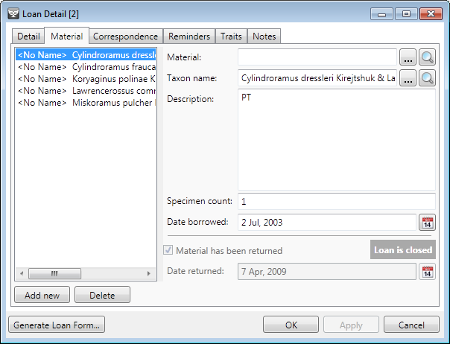
Information about the items in the loan is found on the Material tab. Items can be based on material records stored in the BioLink database; taxa found in the Taxon Explorer or they can be based on a short description. Any number of items can be assigned to a loan. To add a new item press the Add New button near the bottom left of the window. Its details can then be entered in the fields on the right of the window. To edit an existing item, select it in the list and edit its details on the right. To delete a previously entered item, select it and press the Delete button.
The following details can be recorded for each item in a loan.
Material, Taxon name and Description: These three fields are used to describe the item being included in the loan. The Material and Taxon Name fields are filled from the Site Explorer and Taxon Explorer, respectively. To open these explorers press the ellipsis button (with the three dots) to the right of the field. Find the item of interest and use the Explorer’s Select button or drag and drop to copy the item to the Loan Detail window. Alternately, the name of the item can be typed directly into these two fields. BioLink will then look up the name in the Explorer. If a single match is found, the matching name will be used; if more than one match is found, a list of names will be displayed where the appropriate name can be selected. If no matches are found an error message will be given and the cursor will remain in the field.
Once the field has been filled, the magnifying glass button can be used to view details for the entered item. While any item in the Site Explorer can be transferred, in most cases it will be a material record. If a material record is copied and it contains an identification, this identification will appear in the Taxon Name field. This name can be overwritten using the Taxon Explorer if required. The Description field can be used if the loan item doesn’t have a material record or its taxon name isn’t in the Taxon Explorer.
Specimen count: The number of specimens or units being lent.
Date borrowed: The date this item was added to the loan. Generally this will be the date the loan originated, but it may be a later date if this item was added to an existing loan.
Material has been returned and Date returned: Each item in a loan can be returned separately from other items. To indicate an item has been returned, select the item in the list and click the Material Has Been Returned checkbox. The date it was returned can then be entered in the Date Returned field (today’s date is automatically entered by default). If the entire loan is being returned or if the final item in a loan is being returned, the This Loan is Closed/Inactive checkbox on the Detail tab should be checked to close the loan.

Correspondence tab
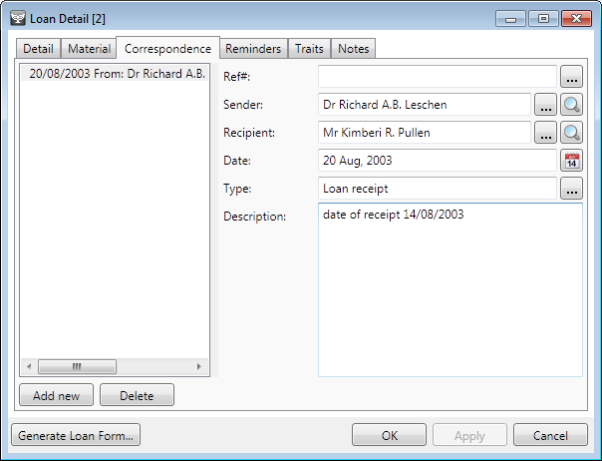
Correspondence concerning a loan can be managed on the Correspondence tab. Any number of correspondence records can be tracked for a loan. To add a new correspondence record press the Add New button near the bottom left of the window. Its details can then be entered in the fields on the right of the window. To edit a record, select the required item from the list and edit its details on the right. To delete a previously entered record, select it in the list and press the Delete button.
The following details can be recorded for each correspondence record.
Reference Number: A reference number for the record.
Sender and Recipient: The name of the person sending and receiving the correspondence. These names can be typed directly into the field or transferred from Contacts. If typed directly, BioLink will look up the name in Contacts: If a single match is found, the matching name will be used. If more than one match is found, a list of names will be displayed where the appropriate name can be selected. If no matches are found an error message will be given and the cursor will remain in the field.
Date: The date of the correspondence.
Type: The type or category of the correspondence.
Description: A short description of the correspondence.

Reminders tab
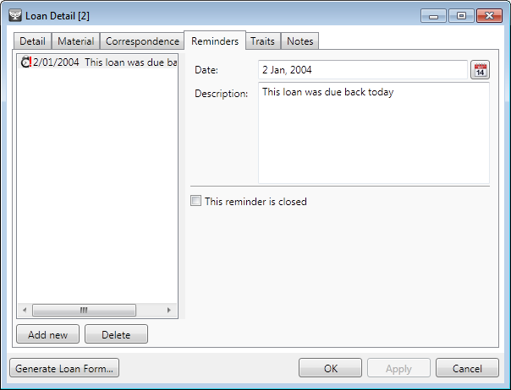
Reminders act as a kind of alarm clock. They can be easily set and then later checked to determine which ‘have gone off’. They are most commonly used to track overdue loans. Reminders are set on the Reminders tab and managed using the Reminders window.
Any number of reminders can be set for a loan. To add a new reminder press the Add New button near the bottom left of the window. Its details can then be entered in the fields on the right of the window. To edit a reminder, select it in the list and edit its details on the right. To delete a previously entered reminder, select it and press the Delete button.
The following details can be recorded for each reminder:
Date: The date the reminder will be triggered or go off. Clicking the Calendar button to the right of the field will open a calendar window where a date can be selected.
Description: A short description of the reminder.
This reminder is closed: A checkbox which will deactivate a reminder. Deactivated reminders remain in the list but are not active.

Managing reminders
Reminders are managed using the Reminders window. To open this window select the Reminders command from the Loans button of the main BioLink toolbar. When opened, the Reminders window contains a list of all loans that have reminders that have expired. To view the details of individual loans select the loan of interest in the list and either double click it or click the right mouse button or open the Edit menu and select the Edit Loan Details command. This will open the Loan Detail window with the selected loan. To turn off a reminder click the Reminders tab and check the This Reminder is Closed checkbox.

Traits and Notes tabs
Traits and Notes are used to store information not directly supported by BioLink. This can include information that is specific to a particular loan or contact, or to a project or other activity. Traits and Notes are organised by category. Traits are recorded as a single word or short phrase while Notes are recorded as a block of text that can include formatting as required.

Adding Traits
To add a Trait select the Traits tab on the Loan Detail window. Press the Add New button to open a window listing the titles of previously used Traits. Select a title for the new Trait or create a new one using the Add New button near the bottom of the list. Press the OK button on the Trait window to create the new Trait and return to the Detail window. The value for this Trait can now be entered in the Trait Value field on the right side of the Traits tab. A comment concerning this Trait can also be included.
To save the new Trait, press the OK or Apply button. To remove a Trait, select the Trait and press the Delete button.

Adding Notes
To add a new Note, select the Notes tab. Press the Add New button to open a window listing the titles of previously used Notes. Select a title for the new Note or create a new title using the Add New button near the bottom of the list. Press the OK button on the Phrase window to create the new Note and return to the Detail window. The text for this Note can now be entered in the right side of the Notes tab. To format text, including bold, italics, underlining, font size and font colour, select text followed by the appropriate toolbar button. Symbols can be entered by pressing the sigma button. The Note text can be printed and copied or cut to the clipboard using the toolbar, and the contents of the Clipboard can be added to a Note using the Paste button.
To save the new Note press the OK or Apply button. To remove a Note, select it in the list and press the Delete button.

Loan forms
Loan forms are managed using the Loan Forms Template window. This window lists all available loan forms and allows the addition and deletion of loan forms from BioLink. To open this window, locate a loan using either the Find Loans or Contacts windows and open its details (see Loan Details above). Once open press the Generate Loan Form button.

Creating a loan form
Loan forms are stored as files in RTF format. They contain embedded tags that indicate where information from the loan should be inserted. When generating a loan form, BioLink searches for these tags and replaces them with the requested information. This new file is then opened in a word processor where it can be printed or saved to disk. This method of managing loan forms means that they can be formatted in any way required and can include graphics and institution-specific text as required.
To create a new loan form, open a word processor that can save in RTF format. Microsoft’s WordPad, which is included with Windows, works well for this purpose. Open a new document and enter the standard text that will appear on all loan forms. This will include such things as the name of the institution, possibly a logo, and terms and conditions of the loan.
Information about the details of the loan are divided into two sets, general information and material information. General information includes such things as loan numbers and requestor name while material information concerns the items included in the loan. General information can be placed anywhere on a loan form while material information is placed in a table. The details and placement of this table can be specified but the format of the table is set by BioLink. To enter information from a BioLink loan, enter the tags listed below under Loan Form Tags. Each tag represents an item from the loan details. The tags can be formatted as required (for example, fonts) and can be embedded in tables (if tables are supported by your word processor: a feature not found in WordPad). The tags are enclosed in double angle brackets (<< >>) to distinguish them from plain text. Material information is contained in the tag <<Material(detail, detail)>> where detail represents information about each item of material.
A typical loan form template might look something like this:

Biolink Loan Form

Loan Reference Number: <<vchrLoanNumber>>

Requested By: | <<RequestorTitle>> <<RequestorGivenName>> <<RequestorName>>
Receiver: | <<ReceiverTitle>> <<ReceiverGivenName>> <<ReceiverName>>
Date Initiated: | <<dtDateInitiated>>
Date Due: | <<dtDateDue>>
Transfer Method: | <<vchrMethodOfTransfer>>
Permit Number: | <<vchrPermitNumber>>
Return Type: | <<vchrTypeOfReturn>>

Terms and conditions:

Restrictions: <<vchrRestrictions>>

Material on loan:

<<Material(vchrMaterialName,vchrTaxonName,vchrMaterialDescription, vchrNumSpecimens)>>

Signed

<<OriginatorTitle>> <<OriginatorGivenName>> <<OriginatorName>>

This template would produce a loan form something like this:

Biolink Loan Form

Loan Reference Number: 99-326

Requested By: | Steve Shattuck
Receiver: | Steve Shattuck
Date Initiated: | 7/22/1999
Date Due: | 7/22/2000
Transfer Method: | hand carried
Permit Number:
Return Type:

Terms and conditions:

Restrictions: None

Material on loan:

, Sphinctomyrmex, Unsorted material, 142 workers.

, Cerapachys, Unidentified material, 47 workers.

Signed

Graham Crompton

Adding a loan form to BioLink
Once the loan form has been completed in the word processor it should be saved in RTF format to the local hard disk. The form will now need to be added to BioLink. To add the form, press the Manage Forms button. This will open a list of existing forms. Press the Add New button to open the File Open dialog where the loan form can be specified. Press Open to add this new loan form to BioLink. To delete an existing loan form, select it in the list and press the Delete key. Finally, press the OK or Apply buttons to save these changes.

Loan form tags
The following tags relate to general loan information. These tags are enclosed in double angle brackets (<< >>) and can be placed anywhere on a loan form.
vchrLoanNumber: the Loan Number assigned to the loan
dtDateInitiated: the date the loan was established or created
dtDateDue: the date the loan is due
vchrMethodOfTransfer: the method used to transfer the loan
vchrPermitNumber: the permit number associated with the loan
vchrTypeOfReturn: an indication of how the loan was returned
vchrRestrictions: notes on restrictions placed on the loan
dtDateClosed: the date the loan was closed
bitLoanClosed: true if the loan is closed, false if it is currently open
RequestorTitle: the title of the person requesting the loan
RequestorGivenName: the given name of the requestor
RequestorName: the surname of the requestor
ReceiverTitle: the title of the person receiving the loan
ReceiverGivenName: the given name of the receiver
ReceiverName: the surname of the receiver
ReceiverPostalAddress: the postal address of the receiver
ReceiverStreetAddress: the street address of the receiver
OriginatorTitle: the title of the person authorising the loan
OriginatorGivenName: the given name of the authorising person
OriginatorName: the surname of the authorising person
OriginatorPostalAddress: the postal address of the authorising person
OriginatorStreetAddress: the street address of the authorising person

The following tags relate to material details. They are included inside the Material tag (for example, <<Material(vchrNumSpecimens,vchrTaxonName,vchrMaterialDescription)>>. The material tag can be placed anywhere on a loan form and is replaced with a table when the loan form is generated.
vchrNumSpecimens: the number of specimens included in this item
vchrTaxonName: the taxonomic name assigned to this item (taken from Material Details)
vchrMaterialDescription: a description of the item
dtDateAdded: the date this item was added to the loan
dtDateReturned: the date this item was returned
bitReturned: true if the item has been returned, false if the item is still on loan
vchrMaterialName: the name of the material (taken from Material Details)

Contacts
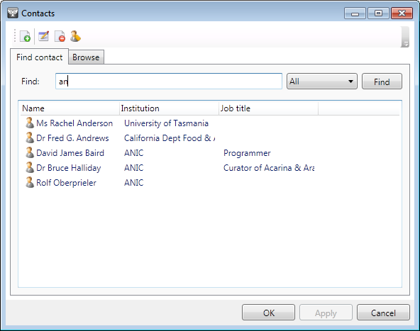
The Contacts window contains a list of all contacts in a BioLink database. This window is the primary way of locating contacts, adding new contacts and deleting existing ones, and updating a contact’s details. To open the Contacts window select the Contacts command under the Loans button on the main BioLink toolbar.
There are two ways of finding contacts using the Contacts window, searching and browsing. To search for a contact, open the Find Contact tab and enter a name or other detail in the Find box, optionally select the type of item to search for in the list box to its right, and click the Find button. A list of contacts matching the Find value will be displayed in the lower part of the window. To browse for a contact, click the Browse tab. This will open a panel with tabs on its right side. These tabs divide the contacts into sets based on their surnames. Clicking a tab will show a list of contacts. The required contact can then be selected.
Once a contact has been located its details can be viewed by double clicking it, clicking the first toolbar button or clicking the right mouse button or opening the Edit menu and selecting the Edit Details command. To create a new contact click the second toolbar button or click the right mouse button or open the Edit menu and select the Add New Contact command. To delete a contact select it and click the third toolbar button or click the right mouse button or open the Edit menu and select the Delete Contact command. To view a list of loans involving the selected contact, click the fourth toolbar button or click the right mouse button or open the Edit menu and select the Loans command.
To transfer a contact to a Loan Detail window either click the Select button or use drag and drop.

List of loans for a person
A list of loans involving a person in the Contacts list can be generated using the Loans command on the Edit menu of the Contacts window. To open this list locate the person of interest in Contacts and press the right mouse button or open the Edit menu and select the Loans command. A list of the person's loans will be displayed.
To edit one of the listed loans either double click it or select it and click the right mouse button or open the Edit menu and select the Edit Loan Details command. This will open the Loan Detail window for the selected loan. To delete a loan select it in the list and click the right mouse button or open the Edit menu and select the Delete Loan command. To create a new loan click the right mouse button or open the Edit menu and select the Add New Loan command.

Contact details
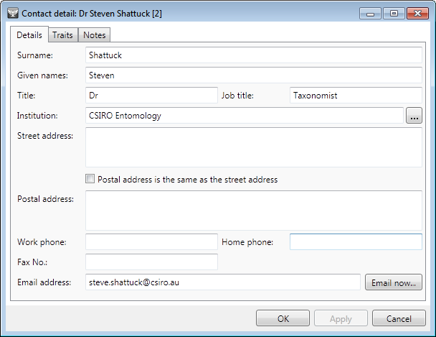
Within BioLink, ‘contacts’ are individuals who are involved in loans. They borrow or receive loans and authorise loans. The Contact Detail window contains details relating to these contacts. To open the Contact Detail window first open the Contacts window using the Contacts menu item under the Tools→Loans menu and then use the Find Contacts or Browse tabs to locate the contact of interest. Double click on the contact’s name or click the right mouse button or open the Edit menu and select the Edit Details command. The following details are stored for each contact:
Surname: The surname or last name of the contact.
Given Names: The given or first name(s) of he contact.
Title: The title of the contact.
Job Title: The job title of the contact.
Institution: The institution where the contact is located.
Street Address: The street address of the contact.
Postal Address: The postal or mailing address of the contact. If the Postal and Street addresses are the same, the checkbox between these two fields can be checked. BioLink will then automatically use the Street address for the postal address.
Work Phone Number: The work phone number.
Home Phone Number: The home phone number.
Fax Number: The fax number.
E-mail Address: The e-mail address of the contact. Once an e-mail address has been entered the Mail now button can be pressed to open the e-mail editor (if available).
In addition to the above information, Traits and Notes can also be stored for each contact.
Once information concerning a contact has been entered or updated, press the OK button to save changes and close the Contact Detail window or press the Apply button to save changes and leave the window open.

